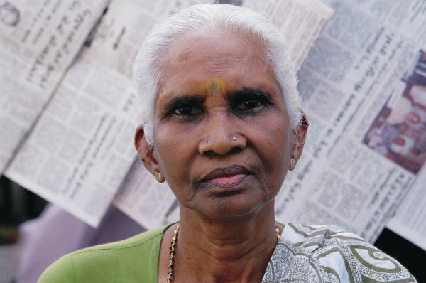
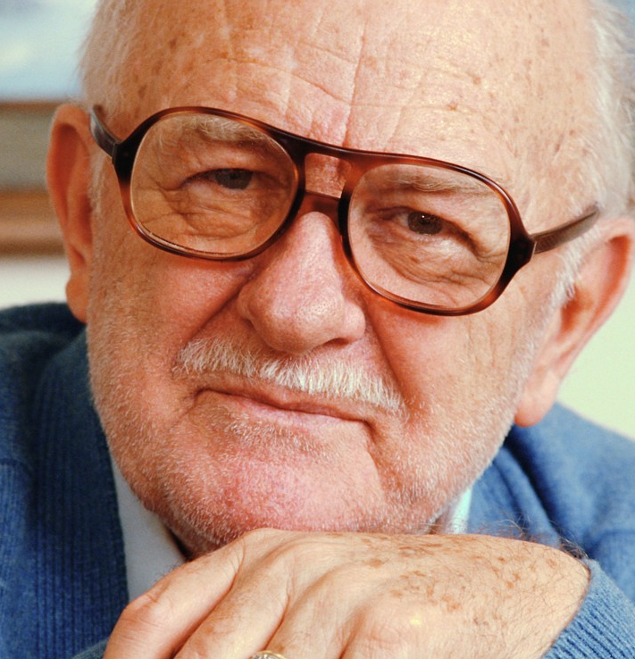

Ontario Seniors for Home & Community Care
Canadian Pensioners Concerned-Ontario Division
Care Watch
Ontario Society (Coalition) of Senior Citizens Organizations

September 10, 2012

Dear Dr. Sinha:

Ontario Seniors for Home & Community Care wishes to congratulate you on being appointed the lead in the development and implementation of the Ontario Seniors Care Strategy. We recognize the importance of your role for current and future generations of seniors in Ontario and are confident that your experience and expertise will contribute to creating a high quality and effective senior care system for Ontario.

As part of your consultation process Ontario Seniors for Home & Community Care would like to offer some suggestions and raise some concerns related to home care for seniors in Ontario.

Ontario Seniors for Home & Community Care is an alliance of seniors organizations committed to ensuring that seniors in Ontario have access to an appropriate balance of medical (physician care, nursing care and rehabilitative care) and supportive in-home services (assistance with personal care, activities of daily living, and transportation). We maintain that adequate, effective and high quality supportive home care services are strong contributing factors to the ability of Ontario seniors to maximize their independence and maintain a high quality of life for as long as possible.

We would also like to share some concerns that we have about the reliability of your consultation process, upon which, it has been stated, you will be basing your recommendations. Our concerns are as follows:

There is a need for broad input from seniors: While we understand that you have been asked to deliver a comprehensive seniors strategy within an abbreviated time frame, we are concerned that you are not getting input from a broad cross section of seniors, including those that are homebound and receiving home care services; those that live in long term care homes; those that are lesbian, gay, bisexual or transgendered; or those that belong to ethno cultural or religious communities. The fact that your survey has been distributed during the summer, primarily by email, and to those who only speak English or French means that many groups have not had access to the survey, e.g.:
- Those with who are not members of the organizations that were selected to distribute or post the survey,
- Those that do not speak or read English or French,
- Those that have little or no access to the Internet
- Those that have not been available during the summer months, etc.

There is a need for a more reliable survey tool: We are concerned that your survey tool will not provide a true picture of what seniors in Ontario want. We believe that your survey tool is flawed for the following reasons:
- It does not capture the ages of the seniors consulted beyond asking if they are over 65. Therefore you have a single picture of what seniors priorities are, and cannot recognize the degree to which these change as seniors age,
- It does not allow participants to identify their own priorities,
- It does not allow participants to rank any two priorities equally,
- Most importantly perhaps, your survey structure does not limit the number of times any one individual or computer can answer the survey. (Several of our members tested this capacity and found that they could answer the survey many times in a row without changing computers.) Undoubtedly, the results of this eminently “hack-able” survey are invalid.

There is a need for consultation with seniors groups: Members of our parent organizations and seniors groups have studied the issue of home care many times over the past two decades. We have consulted with many seniors, gathered much data and written many reports on the need for home care services – from a senior’s perspective. Your consultation process has not allowed us to share these learnings with you or to discuss nuances in the delivery of home care with your research team.

There is a need for a multi-disciplinary approach: Ontario Seniors for Home & Community Care applauds your recognition of the multi-disciplinary nature of home care services and the need for a holistic approach to senior care. This has been evident in your presentations across the Province. We wonder, however, to what extent other departments of government are being consulted in this process. From our perspective it would be important to involve the Ministries of Housing and Municipal Affairs, Community Services and Transportation in the development of a seniors strategy as there is much overlap between the Ministry of Health and Long Term Care and the mandates and services of these other Ministries.

Dr Sinha we applaud your initiative and wish you luck in your deliberations. We would gladly assist you with your work if you provide us with the opportunity to do so. Please contact us to arrange a meeting.

Thank you,

Ontario Seniors for Home & Community Care

Canadian Pensioners Concerned 416 368 5222 canpension@gmail.com
Care Watch 416 590 0455 info@carewatchtoronto.org
Ontario Society (Coalition) of Senior Citizen Organizations
416 785 8570 ocsco@web.net

C.C.
Honourable Deb Matthews, Minister of Health and Long Term Care
Doug Brodhead, Senior Policy Advisor to the Minister of Health and Long Term Care

